Hasil Penelitian
Hasil Uji Validitas Konvergen

SmartPLS Report
Please cite the use of SmartPLS: Ringle, C. M., Wende, S., and Becker, J.-M. 2015. "SmartPLS 3." Boenningstedt:
back to navigation

Construct Reliability and Validity
 | Cronbach's Alpha | rho_A | Composite Reliability | Average Variance Extracted (AVE)
KLK | 0,856 | 0,862 | 0,890 | 0,539
KSDM | 0,915 | 0,929 | 0,934 | 0,704
PTI | 0,879 | 0,883 | 0,908 | 0,588
SAP | 0,912 | 0,919 | 0,926 | 0,536
SPIP | 0,850 | 0,870 | 0,889 | 0,575

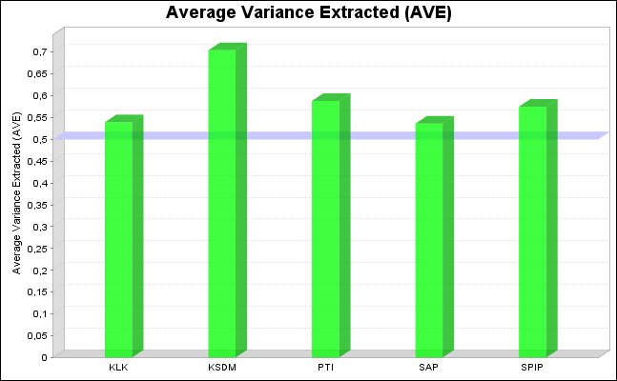

Hasil Uji Validitas Diskriminan
Cross Loadings
 | KSDM |  | SPIP |  | PTI | SAP | KLK
X1.10 | 0,908 |  | 0,577 |  | 0,408 | 0,728 | 0,558
X1.11 | 0,905 |  | 0,510 |  | 0,396 | 0,617 | 0,493
X1.12 | 0,854 |  | 0,407 |  | 0,390 | 0,471 | 0,342
X1.7 | 0,764 |  | 0,496 |  | 0,413 | 0,507 | 0,479
X1.8 | 0,753 |  | 0,474 |  | 0,320 | 0,550 | 0,338
X1.9 | 0,837 |  | 0,489 |  | 0,415 | 0,574 | 0,446
X2.10 | 0,358 |  | 0,738 |  | 0,587 | 0,578 | 0,341
X2.12 | 0,376 |  | 0,845 |  | 0,622 | 0,546 | 0,370
X2.13 | 0,572 |  | 0,649 |  | 0,335 | 0,426 | 0,352
X2.17 | 0,376 |  | 0,679 |  | 0,294 | 0,570 | 0,595
X2.21 | 0,518 |  | 0,749 |  | 0,743 | 0,553 | 0,472
X2.22 | 0,521 |  | 0,864 |  | 0,551 | 0,766 | 0,450
X3.1 | 0,372 |  | 0,507 |  | 0,711 | 0,518 | 0,418
X3.2 | 0,375 |  | 0,593 |  | 0,927 | 0,579 | 0,314
X3.3 | 0,334 |  | 0,547 |  | 0,852 | 0,445 | 0,221
X3.4 | 0,203 |  | 0,573 |  | 0,756 | 0,522 | 0,239
X3.7 | 0,343 |  | 0,422 |  | 0,777 | 0,523 | 0,311
X3.8 | 0,439 |  | 0,619 |  | 0,654 | 0,503 | 0,379
X3.9 | 0,423 |  | 0,438 |  | 0,651 | 0,470 | 0,508
Y1.1 | 0,520 |  | 0,714 |  | 0,428 | 0,750 | 0,431
Y1.10 | 0,481 |  | 0,620 |  | 0,656 | 0,806 | 0,470
Y1.11 | 0,389 |  | 0,539 |  | 0,567 | 0,649 | 0,424
Y1.12 | 0,627 |  | 0,568 |  | 0,520 | 0,829 | 0,592
Y1.13 | 0,655 |  | 0,518 |  | 0,390 | 0,726 | 0,486
Y1.19 | 0,554 |  | 0,536 |  | 0,559 | 0,752 | 0,599
Y1.21 | 0,505 |  | 0,309 |  | 0,546 | 0,593 | 0,361
Y1.24 | 0,374 |  | 0,565 |  | 0,629 | 0,806 | 0,269
Y1.25 | 0,426 |  | 0,521 |  | 0,255 | 0,615 | 0,263
Y1.3 | 0,457 |  | 0,760 |  | 0,417 | 0,814 | 0,446
Y1.4 | 0,580 |  | 0,523 |  | 0,400 | 0,666 | 0,263
Z1.11 | 0,395 |  | 0,334 |  | 0,282 | 0,449 | 0,666
Z1.12 | 0,294 |  | 0,482 |  | 0,372 | 0,494 | 0,715
Z1.14 | 0,379 |  | 0,324 |  | 0,263 | 0,455 | 0,856
Z1.16 | 0,646 |  | 0,511 |  | 0,360 | 0,483 | 0,754
Z1.4 | 0,266 |  | 0,409 |  | 0,332 | 0,308 | 0,633
Z1.5 | 0,408 |  | 0,425 |  | 0,395 | 0,371 | 0,758
Z1.8 | 0,317 |  | 0,427 |  | 0,297 | 0,411 | 0,737

Hasil Uji Composite Reliability dan Cronbach Alpha
SmartPLS Report
Please cite the use of SmartPLS: Ringle, C. M., Wende, S., and Becker, J.-M. 2015. "SmartPLS 3." Boenningstedt:
back to navigation
Construct Reliability and Validity
 | Cronbach's Alpha | rho_A | Composite Reliability | Average Variance Extracted (AVE)
KLK | 0,856 | 0,862 | 0,890 | 0,539
KSDM | 0,915 | 0,929 | 0,934 | 0,704
PTI | 0,879 | 0,883 | 0,908 | 0,588
SAP | 0,912 | 0,919 | 0,926 | 0,536
SPIP | 0,850 | 0,870 | 0,889 | 0,575

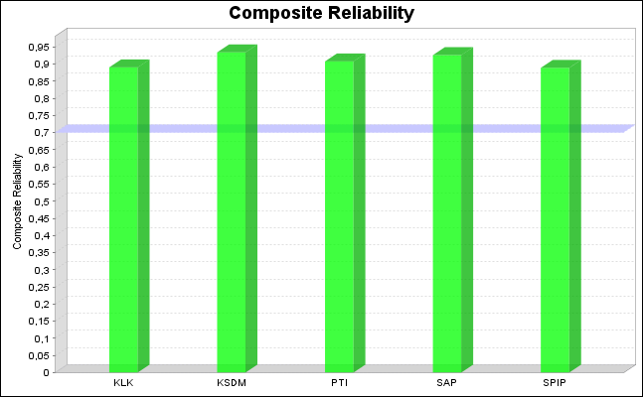
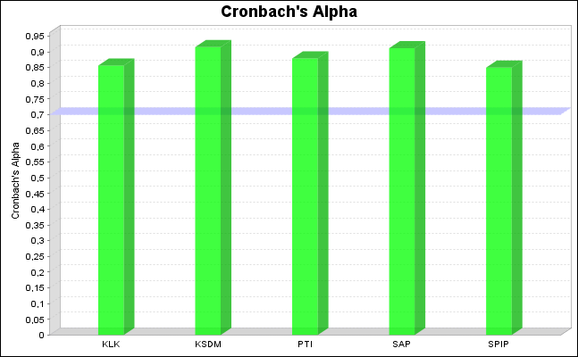

Hasil Koefisien Determinasi R-Square
SmartPLS Report
Please cite the use of SmartPLS: Ringle, C. M., Wende, S., and Becker, J.-M. 2015. "SmartPLS 3." Boenningstedt:
back to navigation

Quality Criteria
 | R Square | R Square Adjusted
KLK | 0,347 | 0,329
SAP | 0,710 | 0,685

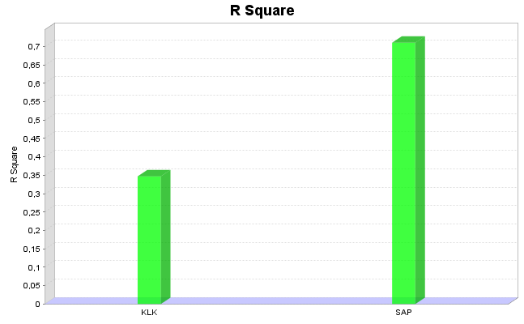
Hasil Uji Blindfolding
SmartPLS Report
Please cite the use of SmartPLS: Ringle, C. M., Wende, S., and Becker, J.-M. 2015. "SmartPLS 3." Boenningstedt:
back to navigation

Construct Crossvalidated Redundancy
Total
 | SSO | SSE | Q² (=1-SSE/SSO)
KLK | 266,000 | 226,288 | 0,149
KSDM | 228,000 | 228,000
PTI | 266,000 | 266,000
SAP | 418,000 | 284,061 | 0,320
SPIP | 228,000 | 228,000

Hasil Uji Bootsrapping
SmartPLS Report
Please cite the use of SmartPLS: Ringle, C. M., Wende, S., and Becker, J.-M. 2015. "SmartPLS 3." Boenningstedt:
back to navigation
Final Results
Path Coefficients
Mean, STDEV, T-Values, P-Values

 | Original Sample (O) | Sample Mean (M) | Standard Deviation (STDEV) | T Statistics (|O/STDEV|) | P Values
KSDM -> SAP | 0,349 | 0,351 | 0,158 | 2,202 | 0,014
PTI -> SAP | 0,221 | 0,202 | 0,137 | 1,610 | 0,054
SAP -> KLK | 0,589 | 0,619 | 0,111 | 5,313 | 0,000
SPIP -> SAP | 0,413 | 0,474 | 0,197 | 2,101 | 0,018

Total Indirect Effects (Mediation Effects)
 | Original Sample (O) | Sample Mean (M) | Standard Deviation (STDEV) | T Statistics (|O/STDEV|) | P Values
KSDM -> SAP->KLK | 0,205 | 0,220 | 0,106 | 1,941 | 0,026
SPIP->SAP -> KLK | 0,243 | 0,263 | 0,122 | 1,995 | 0,023
PTI -> SAP->KLK | 0,130 | 0,144 | 0,093 | 1,408 | 0,080

